Garden creatures

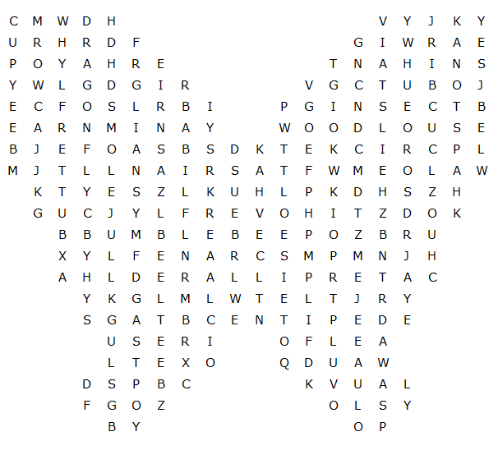

caterpillar grasshopper bumblebee butterfly centipede

dragonfly ladybird cranefly hoverfly cricket spider

insect earwig beetle hornet snail mole worm slug

wasp flea moth fly bee ant woodlouse
Garden creatures – Solution

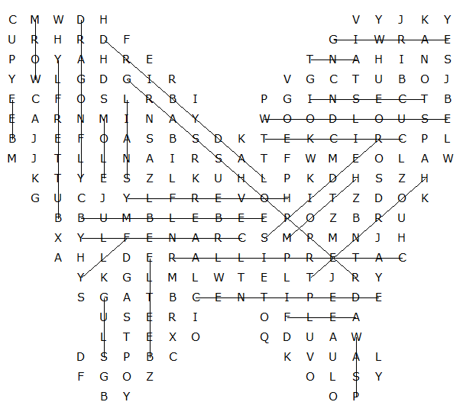

This worksheet was made up using TOOLBOX by Discovery Educational Software.

